Create Folder Structure

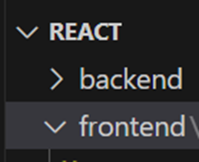

Co to the front end directory and run following commands :

• cd frontend

• npm install -g create-react-app

• npx create-react-app src

Then a src folder is created in frontend folder . Go to src directory by cd src

And run

• npm start

Deployment server will be started wih port number 3000

Now go to src->app.js file and delete header tab total code and app.css whole css code

Write hello world in the app.js file function code

Successfully Written Hello World

Creating file as header.js and do following steps : Header file consists of :

import React from ‘react’;

Const Header = () =>{

return ( <h1>Hello</h1> );

}

export default Header;

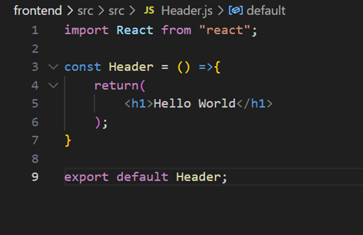

and now in app.js file remove hello world and import Header from ‘/path to file’;

and in return function write this to import that function component to app.js

<Header/>

contents of app.js now :

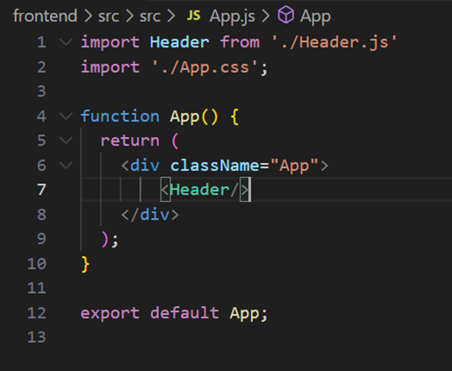

Remember steps:

if any file created then first step import react and next export default statement these two statements are mandatory to export and import files in app.js

We are doing this import , export all because we cant write whole code in app.js , it maked main page in to clumpsy so we arwe creating separate files and importing those files in to app.js as c omponents thus no issues with code understanding and implementing

Now create these files :

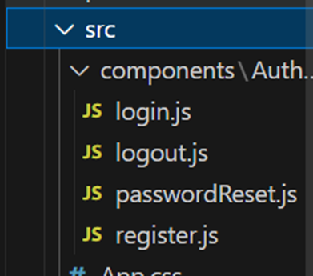

as in src create components and in components crerate auth , and in auth create these 4 files named as

Login,logout,passwordReset,register js files

And import these files in to app.js

Now app.js and login . js files consists of :

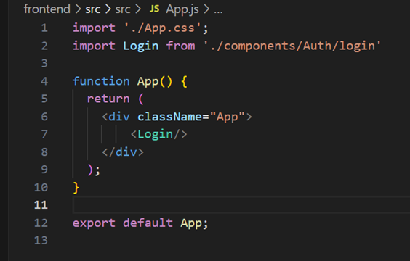

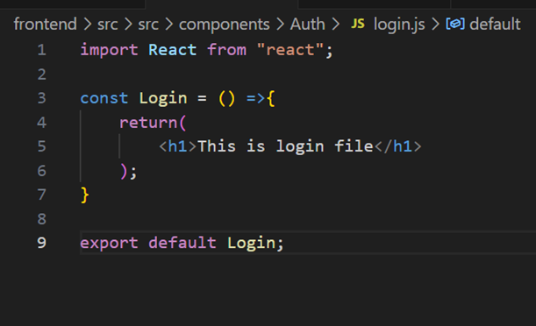

Output :

Now repeat same process to all files and get the output :

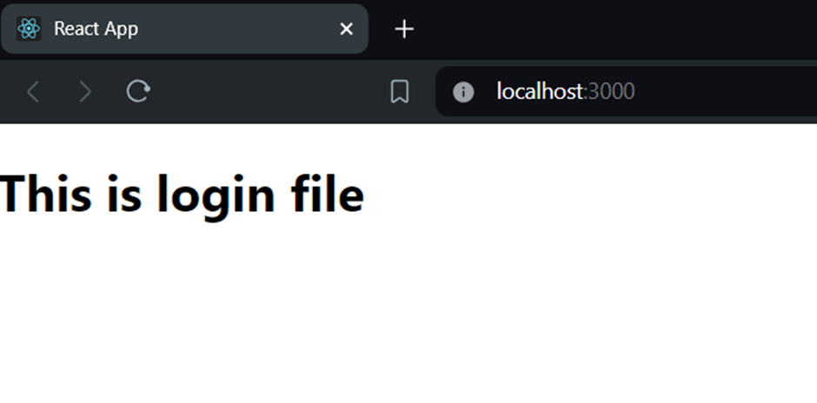

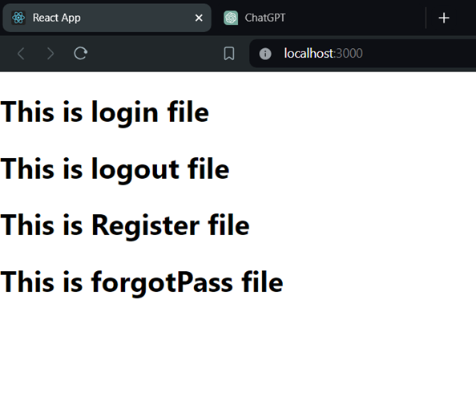

Anthe inka cheppan bye

Open created backend/api folder

Run command :

*Npm init  
npm install –save express mongoose socket.io jsonwebtoken bcrypt dotenv nodemon*

*Npm install*

After this all required packages are installed can be checked at package.json(verify here)

Add this code in **app** .js: in frontend

*const express = require('express');*

*const app = express();*

*const cors = require('cors');*

*const bodyParser = require('body-parser');*

*const PORT = 3001;*

*app.use(express.json());*

*app.use(cors());*

*app.use(bodyParser.json());*

*// Middleware*

*app.use(cors());*

*app.use(bodyParser.json());*

*// POST route to handle incoming messages*

*app.post('/send-message', (req, res) => {*

*const message = req.body.message;*

*console.log('Received message:', message);*

*res.send({ success: true, message: 'Message received successfully.' });*

*});*

*// Start the server*

*// const PORT = 3001;*

*app.listen(PORT, () => {*

*console.log(`Server is running on port ${PORT}`);*

*});*

Update **container**.js after creating frontend-src-compomnents-container.js

*import React from 'react';*

*import { useState } from 'react';*

*const Container = () => {*

*const name = "Sai Pavan Velidandla";*

*const [msg,setMsg] = useState('');*

*const [blocks,setBlocks] = useState([]);*

*const update = (e) => {*

*setMsg(e.target.value)*

*}*

*const send = () => {*

*if (msg.trim() !== '') {*

*axios.post('http://localhost:3001/send-message', { message: msg })*

*.then(response => {*

*console.log(response.data); // Log the response from the backend*

*setBlocks([...blocks, { msg: msg }]);*

*setMsg('');*

*document.querySelector("#msg").focus();*

*})*

*.catch(error => {*

*console.error('Error sending message:', error);*

*});*

*}*

*};*

*return (*

*<div className='container'>*

*<header>*

*<h3>SLACK4E</h3>*

*<menu>*

*<li className='active'>Channels</li>*

*<li>Content</li>*

*<li>Live Stream</li>*

*<li>Students</li>*

*<li>Instructors</li>*

*</menu>*

*</header>*

*<div id="main">*

*<div id="sidebar">*

*<menu>*

*<li className='active'># Sales Team</li>*

*<li># Marketing Team</li>*

*<li># Development Team</li>*

*<li># Testing Team</li>*

*<li># Product Team</li>*

*</menu>*

*<li id="lo">Logout</li>*

*</div>*

*<div id="content">*

*<div id="blocks">*

*{blocks.map((block,index) => (*

*<div className={index % 2 === 0 ? "block left" : "block right"} key={index}>*

*<h4>{name}</h4>*

*<p>{block.msg}</p>*

*</div>*

*))}*

*</div>*

*<div id="msgbox">*

*<input type="text" id="msg" value={msg} placeholder="Type your message" onChange={update}/>*

*<button onClick={send}>Send</button>*

*</div>*

*</div>*

*</div>*

*</div>*

*)*

*}*

*export default Container;*

*Update app.js in express folder const express = require('express');*

*const cors = require('cors');*

*const bodyParser = require('body-parser');*

*const app = express();*

*// Middleware*

*app.use(cors());*

*app.use(bodyParser.json());*

*// POST route to handle incoming messages*

*app.post('/send-message', (req, res) => {*

*const message = req.body.message;*

*console.log('Received message:', message);*

*res.send({ success: true, message: 'Message received successfully.' });*

*});*

*// Start the server*

*const PORT = 3001;*

*app.listen(PORT, () => {*

*console.log(`Server is running on port ${PORT}`);*

*});*